1. Difference equation

y(n) = b0 x(n) + G * x(n-N)

b0 = 1.0

G = 0.8

RATE = 16000

delay_sec = 0.05

N = int (RATE * delay_sec )

N = 800

y(n) = (1.0)* x(n) + (0.8) * x(n-800)

Y(Z)

2. Transfer Function

H(Z) = 1 + (0.8) ×

3. Impulse Response

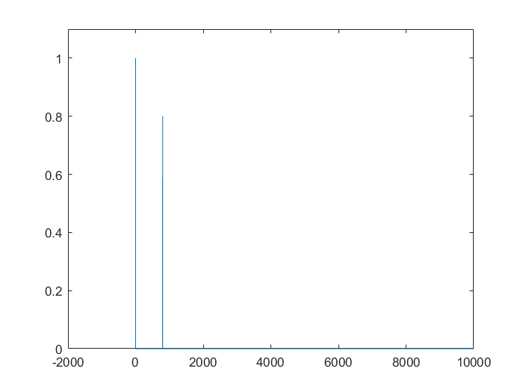

h(n) = δ + 0.8 × δ(n-800)

4. Pole-zero diagram

